JavaScript Assignment #3

**Part 1: What’s your name? Using a Products Form**

[Paste your part 1 screen shot below]

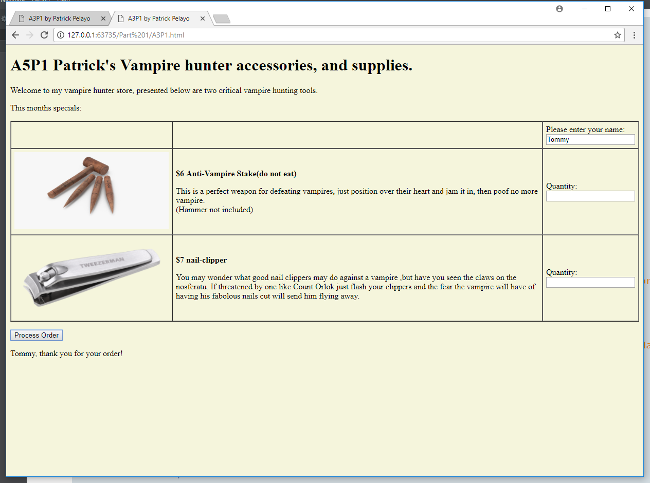

[Paste your part 1 Code below]

**<!DOCTYPE html>**

**<html lang="en">**

**<head>**

**<meta charset="utf-8">**

**<title>A3P1 by Patrick Pelayo</title>**

**<script>**

**//Constants**

**const prodPrice = [6,7];**

**</script>**

**</head>**

**<body>**

**<h1>A3P1 STORE NAME GOES HERE</h1>**

**<p>STORE INTRODUCTION GOES HERE</p>**

**<p>This months specials:</p>**

**<form>**

**<table border="1" cellspacing="0" cellpadding="6" summary="Table of product images, prices & descriptions">**

**<tbody>**

**<tr>**

**<td>&nbsp;</td>**

**<td>&nbsp;</td>**

**<td>Please enter your name:<br><input type="text" id="txtName" name="txtName">**

**</td>**

**</tr>**

**<tr>**

**<td>PRODUCT IMAGE #1 GOES HERE</td>**

**<td>**

**<p style="font-weight: bold">$1 Widgets</p>**

**<p>PRODUCT #1 DESCRIPTION GOES HERE </p>**

**</td>**

**<td>Quantity:<br><input type="text" id="txtQ1" name="txtQ1"></td>**

**</tr>**

**<tr>**

**<td>PRODUCT IMAGE #2 GOES HERE</td>**

**<td>**

**<p style="font-weight: bold">$2 Thingys</p>**

**<p>PRODUCT #2 DESCRIPTION GOES HERE </p>**

**</td>**

**<td>Quantity:<br><input type="text" id="txtQ2" name="txtQ2"></td>**

**</tr>**

**</tbody>**

**</table>**

**<p>**

**<input type="button" value="Process Order" id="btnProcess" onClick="document.getElementById('receipt').innerHTML = document.getElementById('txtName').value + ', thank you for your order!';"**

**</p>**

**</form>**

**<div id="receipt">&nbsp;</div>**

**<script>**

**//This function will change the HTML to the store one<updates page>. Taken from previous assignment**

**(function() {**

**//variables**

**var strN = "A5P1 Patrick's Vampire hunter accessories, and supplies.",**

**strIn = "Welcome to my vampire hunter store, presented below are two critical vampire hunting tools.",**

**prd1D = "This is a perfect weapon for defeating vampires, just position over their heart and jam it in, then poof no more vampire. <br> (Hammer not included)",**

**prd1P = "$" + prodPrice[0] + " Anti-Vampire Stake(do not eat)",**

**prd2D = "You may wonder what good nail clippers may do against a vampire ,but have you seen the claws on the nosferatu. If threatened by one like Count Orlok just flash your clippers and the fear the vampire will have of having his fabolous nails cut will send him flying away.",**

**prd2P = "$" + prodPrice[1] + " nail-clipper",**

**title = "A3P1 by Patrick Pelayo",**

**width = "300",**

**height = "150",**

**temp;**

**//set background beige**

**document.getElementsByTagName("body")[0].style.background = "beige";**

**//change all the html thru javascript**

**document.getElementsByTagName("h1")[0].innerHTML = strN;**

**document.getElementsByTagName("p")[0].innerHTML = strIn;**

**document.getElementsByTagName("p")[2].innerHTML = prd1P;**

**document.getElementsByTagName("p")[3].innerHTML = prd1D;**

**document.getElementsByTagName("p")[4].innerHTML = prd2P;**

**document.getElementsByTagName("p")[5].innerHTML = prd2D;**

**document.getElementsByTagName("title")[0].innerHTML = title;**

**//do the images**

**temp = document.createElement("IMG");**

**temp.src = "stake.jpg";**

**temp.width = width;**

**temp.height = height;**

**document.getElementsByTagName("td")[3].innerHTML = "";**

**document.getElementsByTagName("td")[3].appendChild(temp);**

**//second image**

**temp = document.createElement("IMG");**

**temp.src = "nailClipper.png";**

**temp.width = width;**

**temp.height = height;**

**document.getElementsByTagName("td")[6].innerHTML = "";**

**document.getElementsByTagName("td")[6].appendChild(temp);**

**})();**

**</script>**

**</body>**

**</html>**

**Part 2: Make it Functional!**

[Paste your part 2 screen shot below]



[Paste your part 2 Code below]

**<!DOCTYPE html>**

**<html lang="en">**

**<head>**

**<meta charset="utf-8">**

**<title>A3P2 by Patrick Pelayo</title>**

**<script>**

**//Constants**

**const prodPrice = [6, 7];**

**const keyCodes = { //These are the keyCodes for input masking**

**a: 65,**

**z: 90,**

**tab:9,**

**dot: [110,190],**

**spc: 32,**

**bkspc: 8,**

**zero: 48,**

**nine: 57,**

**zeroNum: 96, //<<numpad**

**nineNum: 105 //<<numpad**

**}**

**//functions**

**//This processes the order**

**function processOrder() {**

**//variables**

**var name = document.getElementById("txtName").value;**

**var items = [document.getElementById("txtQ1").value,document.getElementById("txtQ2").value];**

**var error = "You did not enter all of the required information.";**

**var output = name + ", thank you for your order of " + items[0] + " Anti-Vampire Stake/s and " + items[1] + " nail clipper/s.";**

**//if any value was left blank deny processing and inform user of the problem**

**if (name.length === 0 || items[0].length === 0 || items[1].length === 0){**

**document.getElementById("receipt").innerHTML = error;**

**}else//perform processing**

**{**

**document.getElementById("receipt").innerHTML = output;**

**}**

**}**

**//This function checks the name field for invalid input, and masks the invalid input from applying**

**function inpMsk01(e) {**

**//define the static variables**

**if (typeof inpMsk01.spcFlag == "undefined" || typeof inpMsk01.dotFlag == "undefined") {**

**inpMsk01.spcFlag = false;**

**inpMsk01.dotFlag = false;**

**}**

**//store the keycode value, and the value in the name field**

**var val = e.keyCode;**

**var name = document.getElementById("txtName").value;**

**//check for invalid input Ensure first character is only characters**

**if (name.length === 0 && !((val >= keyCodes.a && val <= keyCodes.z) || (val === keyCodes.tab))) {**

**e.preventDefault();**

**} else { //ensure only alphabet, backspace (. or space as input when flags false)**

**if (!((val >= keyCodes.a && val <= keyCodes.z) || val === keyCodes.tab || val === keyCodes.dot[0] || val === keyCodes.dot[1] || val === keyCodes.bkspc || val === keyCodes.spc) || ((inpMsk01.spcFlag === true && val === keyCodes.spc) || ((inpMsk01.dotFlag === true) && (val === keyCodes.dot[0] || val === keyCodes.dot[1])))) {**

**e.preventDefault();**

**} else {**

**//check for space or . input, set flag to true if entered as input**

**if (val === keyCodes.spc) {**

**inpMsk01.spcFlag = true;**

**} else {**

**if (val === keyCodes.dot[0] || val === keyCodes.dot[1]) {**

**inpMsk01.dotFlag = true;**

**} else { //reset flags if any other input is valid**

**inpMsk01.spcFlag = false;**

**inpMsk01.dotFlag = false;**

**}**

**}**

**}**

**}**

**}**

**//This function is used in event handling for the amount fields, allows numbers only, no spaces**

**function inpMsk02(e) {**

**//variables, set the values**

**var val = e.keyCode;**

**//perform the input masking**

**if(!((val >= keyCodes.zero && val <= keyCodes.nine || (val >= keyCodes.zeroNum && val <= keyCodes.nineNum)) || val === keyCodes.bkspc || val === keyCodes.tab) ){**

**e.preventDefault();**

**}**

**}**

**</script>**

**</head>**

**<body>**

**<h1>A3P2 STORE NAME GOES HERE</h1>**

**<p>STORE INTRODUCTION GOES HERE</p>**

**<p>This months specials:</p>**

**<form>**

**<table border="1" cellspacing="0" cellpadding="6" summary="Table of product images, prices & descriptions">**

**<tbody>**

**<tr>**

**<td>&nbsp;</td>**

**<td>&nbsp;</td>**

**<td>Please enter your name:<br><input type="text" id="txtName" name="txtName">**

**</td>**

**</tr>**

**<tr>**

**<td>PRODUCT IMAGE #1 GOES HERE</td>**

**<td>**

**<p style="font-weight: bold">$1 Widgets</p>**

**<p>PRODUCT #1 DESCRIPTION GOES HERE </p>**

**</td>**

**<td>Quantity:<br><input type="text" id="txtQ1" name="txtQ1"></td>**

**</tr>**

**<tr>**

**<td>PRODUCT IMAGE #2 GOES HERE</td>**

**<td>**

**<p style="font-weight: bold">$2 Thingys</p>**

**<p>PRODUCT #2 DESCRIPTION GOES HERE </p>**

**</td>**

**<td>Quantity:<br><input type="text" id="txtQ2" name="txtQ2"></td>**

**</tr>**

**</tbody>**

**</table>**

**<p>**

**<p>**

**<input type="button" value="Process Order" id="btnProcess" onClick="processOrder();">**

**</p>**

**</p>**

**</form>**

**<div id="receipt">&nbsp;</div>**

**<script>**

**//auto start functions**

**//This function will change the HTML to the store one<updates page>. Taken from previous assignment**

**(function() {**

**//variables**

**var strN = "A5P2 Patrick's Vampire hunter accessories, and supplies.",**

**strIn = "Welcome to my vampire hunter store, presented below are two critical vampire hunting tools.",**

**prd1D = "This is a perfect weapon for defeating vampires, just position over their heart and jam it in, then poof no more vampire. <br> (Hammer not included)",**

**prd1P = "$" + prodPrice[0] + " Anti-Vampire Stake(do not eat)",**

**prd2D = "You may wonder what good nail clippers may do against a vampire ,but have you seen the claws on the nosferatu. If threatened by one like Count Orlok just flash your clippers and the fear the vampire will have of having his fabolous nails cut will send him flying away.",**

**prd2P = "$" + prodPrice[1] + " nail-clipper",**

**title = "A3P2 by Patrick Pelayo",**

**width = "300",**

**height = "150",**

**temp;**

**//set background beige**

**document.getElementsByTagName("body")[0].style.background = "beige";**

**//change all the html thru javascript**

**document.getElementsByTagName("h1")[0].innerHTML = strN;**

**document.getElementsByTagName("p")[0].innerHTML = strIn;**

**document.getElementsByTagName("p")[2].innerHTML = prd1P;**

**document.getElementsByTagName("p")[3].innerHTML = prd1D;**

**document.getElementsByTagName("p")[4].innerHTML = prd2P;**

**document.getElementsByTagName("p")[5].innerHTML = prd2D;**

**document.getElementsByTagName("title")[0].innerHTML = title;**

**//do the images**

**temp = document.createElement("IMG");**

**temp.src = "stake.jpg";**

**temp.width = width;**

**temp.height = height;**

**document.getElementsByTagName("td")[3].innerHTML = "";**

**document.getElementsByTagName("td")[3].appendChild(temp);**

**//second image**

**temp = document.createElement("IMG");**

**temp.src = "nailClipper.png";**

**temp.width = width;**

**temp.height = height;**

**document.getElementsByTagName("td")[6].innerHTML = "";**

**document.getElementsByTagName("td")[6].appendChild(temp);**

**})();**

**//this function sets up the events for the input masking on the fields**

**(function() {**

**//create an event listener which checks for invalid names character values and then for the amounts**

**//I only allow a alphebet character as first entry, I disallow spaces beyond 1, I disallow repeating periods**

**document.getElementById("txtName").addEventListener("keydown", inpMsk01);**

**//I deny anything other than the 10 base numbers**

**document.getElementById("txtQ1").addEventListener("keydown", inpMsk02);**

**document.getElementById("txtQ2").addEventListener("keydown", inpMsk02);**

**})();**

**</script>**

**</body>**

**</html>**

**Part 3: You Receive A Receipt!**  
 [Page Your part 3 Screenshot below]

[Paste your part 3 Code Below your screen shot]

**<!DOCTYPE html>**

**<html lang="en">**

**<head>**

**<meta charset="utf-8">**

**<title>A3P3 by Patrick Pelayo</title>**

**<script>**

**//Constants**

**const prodPrice = [6, 7];**

**const keyCodes = { //These are the keyCodes for input masking**

**a: 65,**

**z: 90,**

**tab:9,**

**dot: [110,190],**

**spc: 32,**

**bkspc: 8,**

**zero: 48,**

**nine: 57,**

**zeroNum: 96, //<<numpad**

**nineNum: 105 //<<numpad**

**}**

**//functions**

**//This processes the order**

**function processOrder() {**

**//variables**

**var name = document.getElementById("txtName").value;**

**var items = [document.getElementById("txtQ1").value,document.getElementById("txtQ2").value];**

**var error = "You did not enter all of the required information.";**

**var subTtl = items[0] * prodPrice[0] + items[1] * prodPrice[1];**

**var output = name + ", thank you for your order of " + items[0] + " Anti-Vampire Stake/s and " + items[1] + " nail clipper/s.<br>" + items[0] + " Anti-Vampire Stake/s @1 each = $" + items[0] * prodPrice[0] + "<br>" + items[1] + " Nail Clipper\s @1 each = $" + items[1] * prodPrice[1] + "<br>Total Balance = $" + subTtl;**

**//if any value was left blank deny processing and inform user of the problem**

**if (name.length === 0 || items[0].length === 0 || items[1].length === 0){**

**document.getElementById("receipt").innerHTML = error;**

**}else//perform processing**

**{**

**document.getElementById("receipt").innerHTML = output;**

**}**

**}**

**//This function checks the name field for invalid input, and masks the invalid input from applying**

**function inpMsk01(e) {**

**//define the static variables**

**if (typeof inpMsk01.spcFlag == "undefined" || typeof inpMsk01.dotFlag == "undefined") {**

**inpMsk01.spcFlag = false;**

**inpMsk01.dotFlag = false;**

**}**

**//store the keycode value, and the value in the name field**

**var val = e.keyCode;**

**var name = document.getElementById("txtName").value;**

**//check for invalid input Ensure first character is only characters**

**if (name.length === 0 && !((val >= keyCodes.a && val <= keyCodes.z) || (val === keyCodes.tab))) {**

**e.preventDefault();**

**} else { //ensure only alphabet, backspace (. or space as input when flags false)**

**if (!((val >= keyCodes.a && val <= keyCodes.z) || val === keyCodes.tab || val === keyCodes.dot[0] || val === keyCodes.dot[1] || val === keyCodes.bkspc || val === keyCodes.spc) || ((inpMsk01.spcFlag === true && val === keyCodes.spc) || ((inpMsk01.dotFlag === true) && (val === keyCodes.dot[0] || val === keyCodes.dot[1])))) {**

**e.preventDefault();**

**} else {**

**//check for space or . input, set flag to true if entered as input**

**if (val === keyCodes.spc) {**

**inpMsk01.spcFlag = true;**

**} else {**

**if (val === keyCodes.dot[0] || val === keyCodes.dot[1]) {**

**inpMsk01.dotFlag = true;**

**} else { //reset flags if any other input is valid**

**inpMsk01.spcFlag = false;**

**inpMsk01.dotFlag = false;**

**}**

**}**

**}**

**}**

**}**

**//This function is used in event handling for the amount fields, allows numbers only, no spaces**

**function inpMsk02(e) {**

**//variables, set the values**

**var val = e.keyCode;**

**//perform the input masking**

**if(!((val >= keyCodes.zero && val <= keyCodes.nine || (val >= keyCodes.zeroNum && val <= keyCodes.nineNum)) || val === keyCodes.bkspc || val === keyCodes.tab) ){**

**e.preventDefault();**

**}**

**}**

**</script>**

**</head>**

**<body>**

**<h1>A3P1 STORE NAME GOES HERE</h1>**

**<p>STORE INTRODUCTION GOES HERE</p>**

**<p>This months specials:</p>**

**<form>**

**<table border="1" cellspacing="0" cellpadding="6" summary="Table of product images, prices & descriptions">**

**<tbody>**

**<tr>**

**<td>&nbsp;</td>**

**<td>&nbsp;</td>**

**<td>Please enter your name:<br><input type="text" id="txtName" name="txtName">**

**</td>**

**</tr>**

**<tr>**

**<td>PRODUCT IMAGE #1 GOES HERE</td>**

**<td>**

**<p style="font-weight: bold">$1 Widgets</p>**

**<p>PRODUCT #1 DESCRIPTION GOES HERE </p>**

**</td>**

**<td>Quantity:<br><input type="text" id="txtQ1" name="txtQ1"></td>**

**</tr>**

**<tr>**

**<td>PRODUCT IMAGE #2 GOES HERE</td>**

**<td>**

**<p style="font-weight: bold">$2 Thingys</p>**

**<p>PRODUCT #2 DESCRIPTION GOES HERE </p>**

**</td>**

**<td>Quantity:<br><input type="text" id="txtQ2" name="txtQ2"></td>**

**</tr>**

**</tbody>**

**</table>**

**<p>**

**<p>**

**<input type="button" value="Process Order" id="btnProcess">**

**</p>**

**</p>**

**</form>**

**<div id="receipt">&nbsp;</div>**

**<script>**

**//auto start functions**

**//This function will change the HTML to the store one<updates page>. Taken from previous assignment**

**(function() {**

**//variables**

**var strN = "A3P3 Patrick's Vampire hunter accessories, and supplies.",**

**strIn = "Welcome to my vampire hunter store, presented below are two critical vampire hunting tools.",**

**prd1D = "This is a perfect weapon for defeating vampires, just position over their heart and jam it in, then poof no more vampire. <br> (Hammer not included)",**

**prd1P = "$" + prodPrice[0] + " Anti-Vampire Stake(do not eat)",**

**prd2D = "You may wonder what good nail clippers may do against a vampire ,but have you seen the claws on the nosferatu. If threatened by one like Count Orlok just flash your clippers and the fear the vampire will have of having his fabolous nails cut will send him flying away.",**

**prd2P = "$" + prodPrice[1] + " nail-clipper",**

**title = "A3P3 by Patrick Pelayo",**

**width = "300",**

**height = "150",**

**temp;**

**//set background beige**

**document.getElementsByTagName("body")[0].style.background = "beige";**

**//change all the html thru javascript**

**document.getElementsByTagName("h1")[0].innerHTML = strN;**

**document.getElementsByTagName("p")[0].innerHTML = strIn;**

**document.getElementsByTagName("p")[2].innerHTML = prd1P;**

**document.getElementsByTagName("p")[3].innerHTML = prd1D;**

**document.getElementsByTagName("p")[4].innerHTML = prd2P;**

**document.getElementsByTagName("p")[5].innerHTML = prd2D;**

**document.getElementsByTagName("title")[0].innerHTML = title;**

**//do the images**

**temp = document.createElement("IMG");**

**temp.src = "stake.jpg";**

**temp.width = width;**

**temp.height = height;**

**document.getElementsByTagName("td")[3].innerHTML = "";**

**document.getElementsByTagName("td")[3].appendChild(temp);**

**//second image**

**temp = document.createElement("IMG");**

**temp.src = "nailClipper.png";**

**temp.width = width;**

**temp.height = height;**

**document.getElementsByTagName("td")[6].innerHTML = "";**

**document.getElementsByTagName("td")[6].appendChild(temp);**

**})();**

**//this function sets up the events for the input masking on the fields**

**(function() {**

**//create an event listener which checks for invalid names character values and then for the amounts**

**//I only allow a alphebet character as first entry, I disallow spaces beyond 1, I disallow repeating periods**

**document.getElementById("txtName").addEventListener("keydown", inpMsk01);**

**//I deny anything other than the 10 base numbers**

**document.getElementById("txtQ1").addEventListener("keydown", inpMsk02);**

**document.getElementById("txtQ2").addEventListener("keydown", inpMsk02);**

**//Process order event**

**document.getElementById("btnProcess").addEventListener("click", processOrder);**

**})();**

**</script>**

**</body>**

**</html>**

**Part 4: Change Your Prices and Pay Your Taxes!**

[Page Your part 4 Screenshot below]

[Paste your part 4 Code Below your screen shot]